HK INSTITUTE OF VOCATIONAL EDUCATION
DEPARTMENT OF INFORMATION AND COMMUNICATIONS TECHNOLOGY

ITP4910 Software Development Project

LAB 11 –Deployment of Applications

Objectives:
- To create installers for applications developed by Visual C#.

Visual Studio 2010 has a Setup Project which can aid us in creating setup for desktop. All of the applications created with Visual Studio 2010 require version 4.0 of the .NET framework on the installation system. In many cases when you deliver your application to users, you may have no idea of the target system configuration. Visual Studio 2010 makes the process of including prerequisites easy and most common requirements can be included by selecting a check box.

- Download ITP4910-Lab08-Solution.zip and unzip it.

- Prepare a README file in the Lab08\bin\Debug folder with your name, the date and the text “Lab 11: Set up Application” in it.

- Create a new Setup Project Lab11 by choosing the Other Project Types → Setup and Deployment → Visual Studio Installer and select the Setup Wizard and click OK.

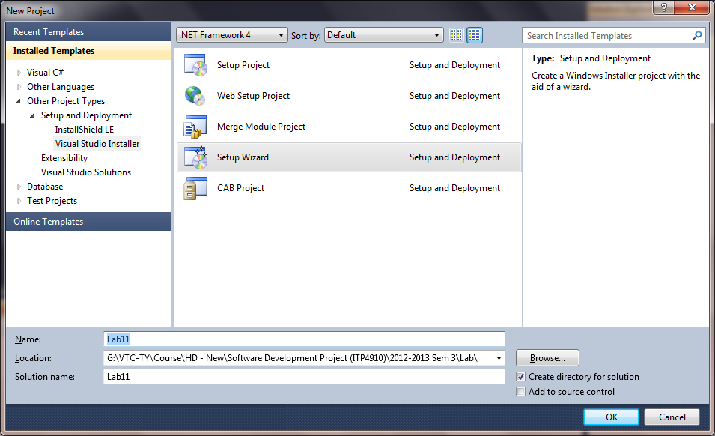

Hint : The Setup Wizard steps you through the process of creating the correct project for the type of application to be deployed.

- Click on the Next button on the first screen of the Setup Wizard.

- Choose the option Create a setup for a Windows application and click on the Next button on the second screen of the Setup Wizard.

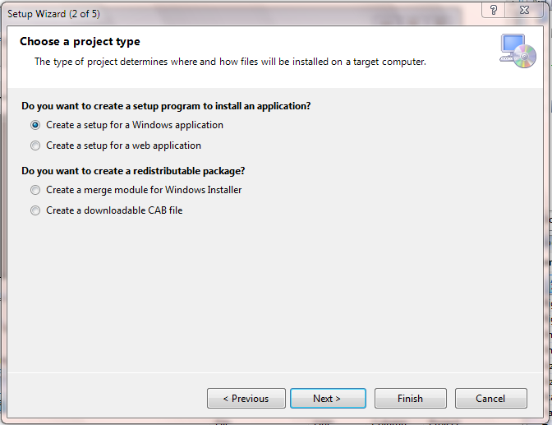

- On the fourth screen of the setup wizard, click on the Add button to add the files Lab08.exe, Lab08.exe.config, README.txt and lib.accdb from Lab08/bin/Debug. Click Next.

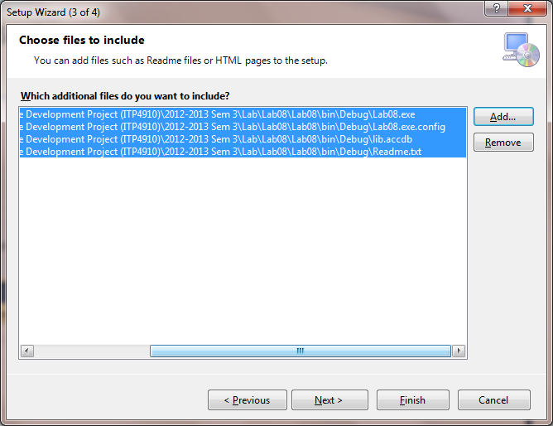

- Click Finish on the last screen.

- Right-click on the Setup project and choose Properties. Click on the Prerequisites button. By default, the Package Files property of the Setup project is set to In Setup File so that all executables and associated dependencies are placed into the .msi file that is created. The Setup project also created a Setup.exe file that checks for minimum requirements, such as the presence of the .NET Framework, prior to calling the .msi file to install the application. Note that by default, the .NET Framework 4.0 Client Profile is selected.

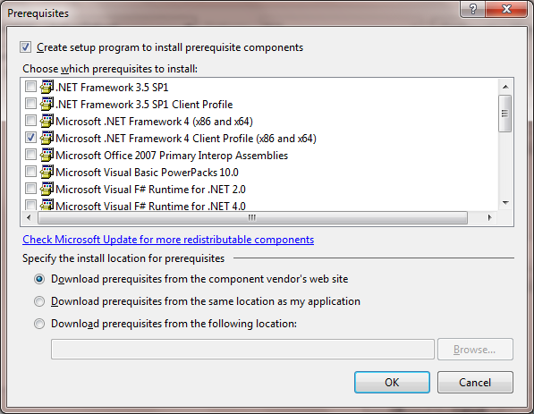

- Click OK twice to close the Prerequisites and Property page windows.

- Change the following properties of the Setup project as shown.

Property | Setting
Author | Your name
InstallAllUsers | True
Manufacturer | VTC
ProductName | Lab 8
Title | Installing Lab 8

- Select the Application Folder in the File System tab and change the property AlwaysCreate to True.

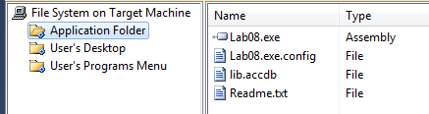

Hint :
- When the property AlwaysCreate is set to True, corresponding application folder will be created in the user’s computer by the setup program.
- The DefaultLocation shows the path of the installation while the value of the parameters [Manufactuer] and [ProductName] were set in the properties Window of the Setup project before.

- Right-click on the Lab08.exe and choose Create Shortcut.

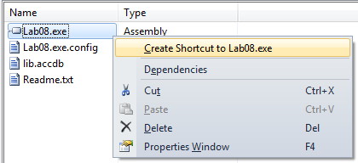

- Type Lab08 as the name of the shortcut. Move the shortcut to the User’s Desktop folder.

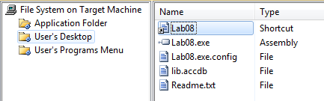

Hint: A shortcut to your program after installation will be created in the User’s desktop.

- Build your Lab11 project. Go the Debug folder under the setup project and two files setup.exe and Lab11.msi will be found. Copy these two files to the desktop.

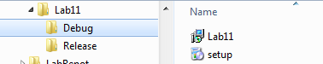

Hint : It is better if you can change the mode to Release before you build your Setup project. In that case, you should find the files in the Release folder under the setup project.

- Double-click on the setup icon to install your application to your computer.

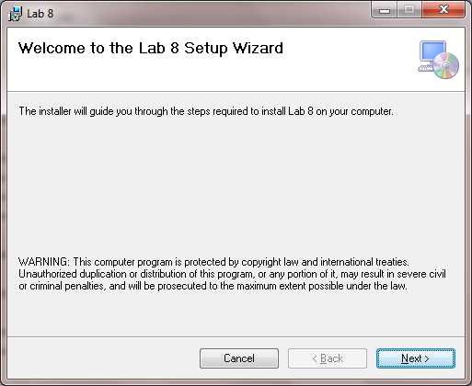

- Accept the default settings during installation. An icon for the Lab 8 should be created successfully on the desktop. Double-click on it to test the application.

- Check the content of the folder ″C:\Program Files\VTC\Lab 8″.

- Try to uninstall the application using the Control Panel.

